
Amazon Interview Worksheet
INVENT AND SIMPLIFY
Definition and Indicators
Invent and Simplify: Leaders expect and require innovation and invention from their teams and always find ways to simplify. They are externally aware, look for new ideas from everywhere, and are not limited by “not invented here”. As we do new things, we accept that we may be misunderstood for long periods of time.
What this looks like in Practice
As a people manager do you… | As an individual contributor do you…
- Simplify and always encourage others to innovate and change inefficient or unnecessarily complex processes?
- Use new ideas and methods to do your job better and enhance the customer experience?
- Create an environment that encourages breakthrough thinking that is simple?  - Encourage innovation and invention for the right reasons, helping others not to unnecessarily reinvent the wheel? | - Think up and implement great ideas and simple solutions?  - Know when not to reinvent the wheel?

Invent and Simplify - Suggested Behavioral Interview Questions
For each question you choose, use a separate STAR Worksheet
Questions for (Manager) in parentheses

- Tell me about the most innovative thing you’ve done and why you thought it was innovative (can also probe with: That sounds more evolutionary than revolutionary – tell me about something you’ve done you feel was truly revolutionary? Ask for one or two additional examples to see if it’s a one off or pattern.)
- People often say the simplest solution is the best. Tell me about a particular complex problem you solved with a simple solution.
- Tell me about a time you were able to make something significantly simpler for customers. What drove you to implement this change?
- Describe a challenging problem or situation in which the usual approach was not going to work. Why were you unable to take the usual approach? What alternative approach did you take? Was it successful?
- Give an example of a creative idea you had that proved really difficult to implement. What was the idea and what made it difficult to implement? Was it successful?
- Tell me about an out-of-the-box idea you had or decision you made that had a big impact on your business.
- Give me an example of how you have changed the direction or view of a specific function/department and helped them embrace a new way of thinking? Why was a change needed?
- How do you draw new thinking and innovation out of your team? Give an example of how your approach led to a specific innovation. (Manager)
- Tell me about a time when you have enabled your team/ a team member to implement a significant change or improvement. (Manager)

STAR WORKSHEET
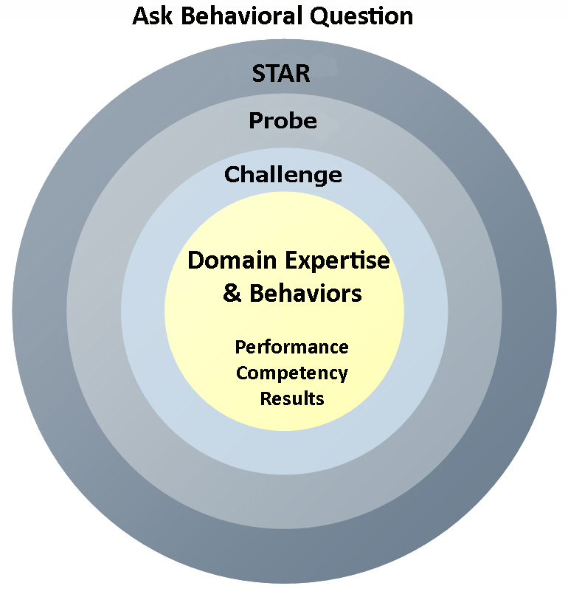
Your Behavioral Question:___________________________________________________________________Leadership Principle:_________________

- Choose behavioral question that provoke specific examples or stories for your assigned Leadership Principle(s).
- Process the example using STAR. Stories have beginnings (Situation/Task), middles (Actions) and ends (Results).
- Once you have established the story, PROBE to dive deeper on your assigned competency (Leadership Principle), get clarity or pursue a concern.
- If appropriate, CHALLENGE the candidate’s statements, decisions or thought process.
S  T | SITUATION/TASK - Describe the situation/task you faced and the context of the story  Answers the questions: where did this occur, when did it happen, why is it important?  Probing Questions:  - Why is this important? What was the goal?  - What was the initial scope of the project? What were the challenges?  - What were the risks and potential consequences if nothing happened?  Challenge Questions:  - Why did you choose this story to illustrate a xyz accomplishment?  - What other stories can you think of that demonstrate.. xyz?  - Could you come up with an example that is more recent? | Notes
A | ACTION - What actions did you take?  Answers the questions: what did you personally own, how did you do it, who else was involved?  Probing Questions:  - Deep probe functional expertise and/or assigned core competency.  - Were you the key driver or project owner?  - What was your biggest contribution? What unique value did you bring?  - What were the most significant obstacles you faced? How did you overcome them?  Challenge Questions:  - What did you do specifically versus the team?  - How did you set priorities…deal with xyz problem… or get manager buy-in?  - What decisions did you challenge? Why? How did you influence the right outcome?
R | RESULTS - How did you measure success for this project? What results did you achieve?  $ Cost savings, revenue generation  # Quantify to understand volume, size, scale  % Percentage change, year over year improvements  Time to market, implementation time, time savings  Impact on the customer, the team  δ Quality improvements  Probing Questions:  - Why did you choose to focus on these results? What other results were important?  - You mentioned revenue, what percentage change is that year over year?  - What trade-offs did you have to make to achieve this? (quality, cost, time)  - I’m concerned about… (the time it took, the volume, the customer impact), tell me more…  Challenge Questions:  - What were the lessons learned? What would you have done differently?  - How would you implement this at Amazon?  - How did these results compare to your actual goals? (refer back to goal stated in Situation)

